

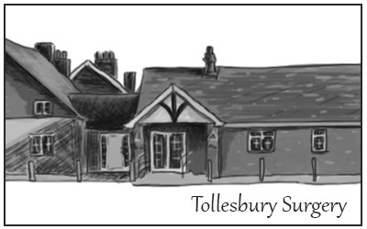

***Drs O D Abazie & C U Ogaziechi***

***Tollesbury Surgery, 25 High Street, Tollesbury,***

***Maldon, Essex CM9 8RG***

***Tel: 01621 869204 / Email:*** [***prescriptions.f81076@nhs.net***](mailto:prescriptions.f81076@nhs.net)

**Consent to Share Confidential Information with a Third Party**

The Data Protection Act 2018 and the ethical codes of conduct of all health care professionals require that medical data be treated with great respect for confidentiality. We are not permitted to share any medical details with a third party without your consent

**Patient Details:**

|  |  |
| --- | --- |
| Patient Name: |  |
| Date of Birth: |  |
| NHS Number: |  |

**I give consent to the sharing of my medical information with:**

|  |  |
| --- | --- |
| Full Name: |  |
| DOB: |  |
| Contact Telephone: Number: |  |
| Relationship to patient: |  |

**What type of information can be shared?**

|  |  |
| --- | --- |
| All | Yes  No |
| Test Results | Yes  No |
| Appointment Information | Yes  No |
| Medications | Yes  No |
| Other: |  |

**Please tell us if this consent is permanent or for a short period of time**:

|  |  |
| --- | --- |
| Permanent | Yes  No |

If temporary, please state: Start date: End date:

**Patient Signature:**

**Date:**

**Please note: -** It is your responsibility to inform us if you change your mind and wish to remove your consent to share your medical information with the above mentioned person.